Name: Phung Gia Minh Khoi…………………………………………………………..

ID student: ……2252381……………………………………………………………………………………………..

1. Question 1

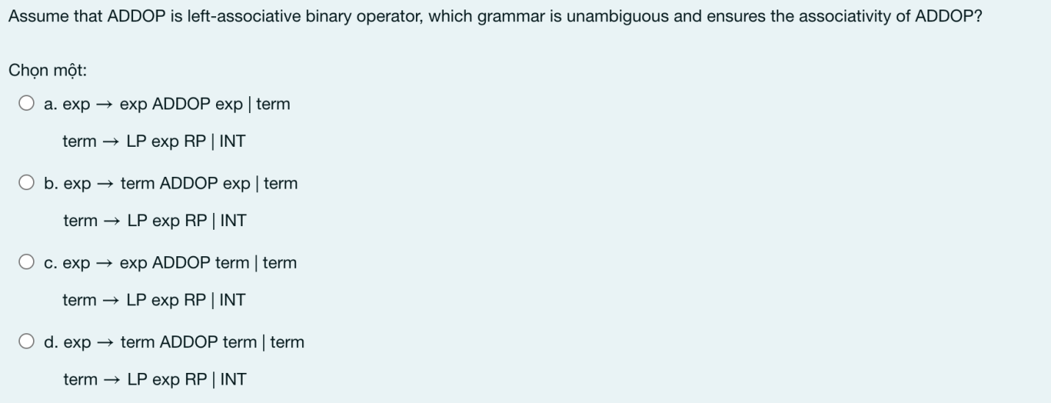

Term > exp => term must be put on right.

1. Question 2

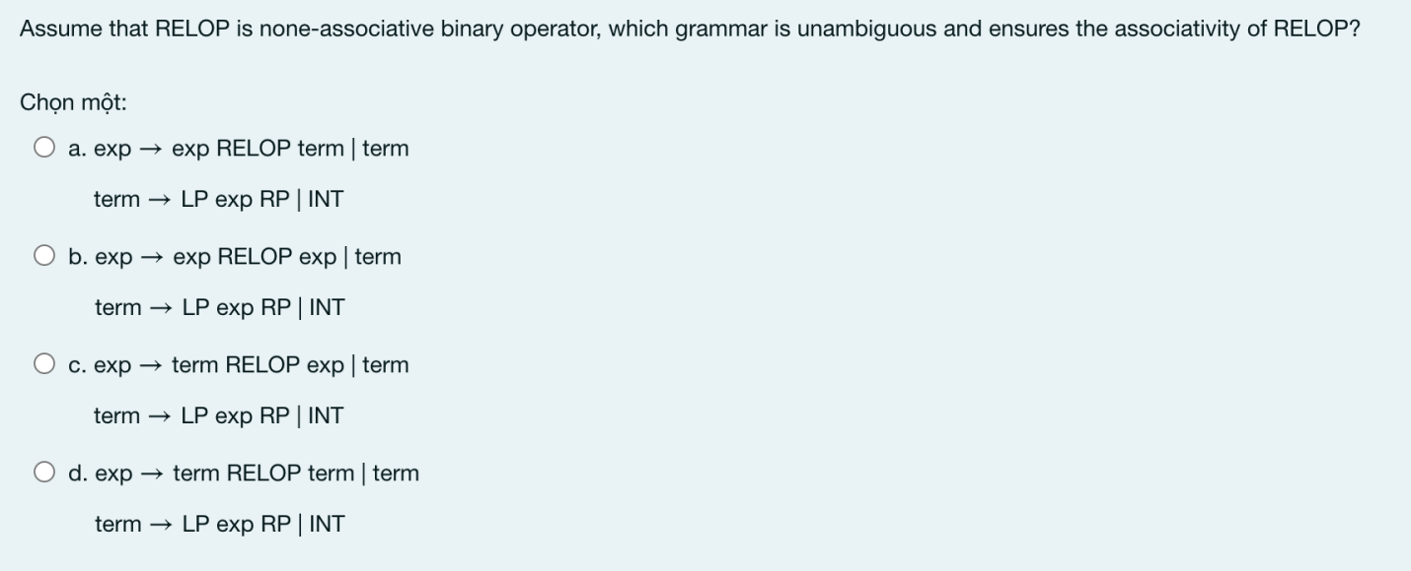

1. Question 3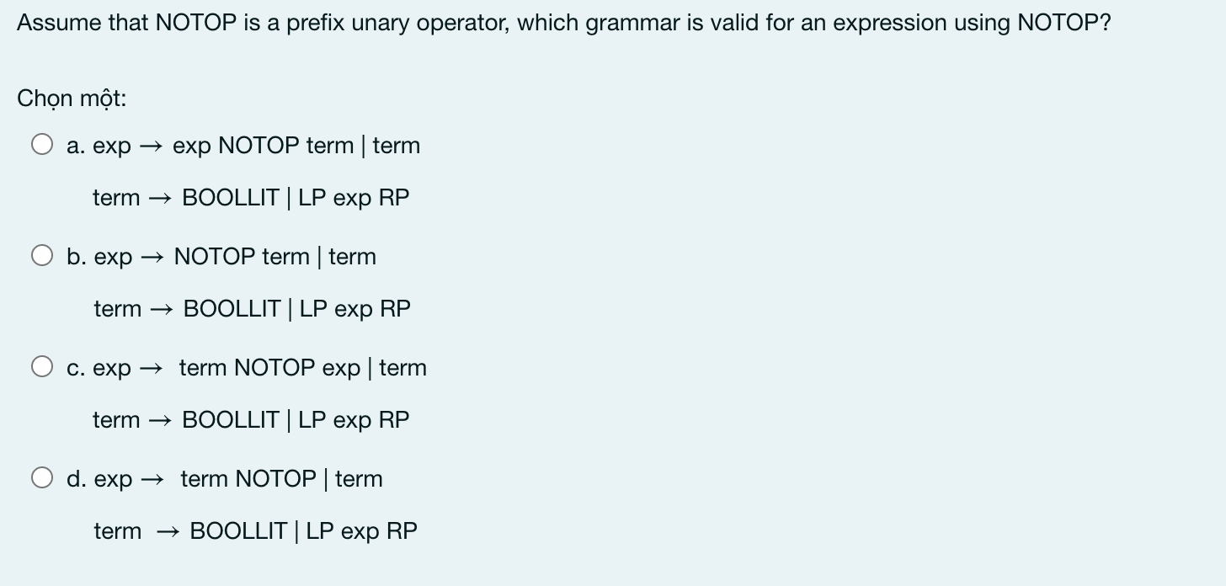
2. On the following grammars,
3. Compare the precedence between + and \*
4. State the associativity of all operations
5. Evaluate 3-4-5\*2

G1:

S 🡪 S+T | S-T |T

T 🡪 T\*F | T/F |F

F🡪 num

1. + < \*
2. (+ == -) < (\* == /)
3. Evaluate 3-4-5\*2 = 3-4-10 = -1-10= -11

G2:

S 🡪 S\*T | S-T |T

T 🡪 F+T | F/T |F

F🡪 num

a.\* < +

b.(\* == -) < (+ == /)

c.Evaluate 3-4-5\*2 = -1-5\*2 = -6\*2 = -12

G3:

S🡪 S\*T |S/T |S+T |T

T🡪 T-T |F

F 🡪 num

a.\* == +

b.(\* == / == +) < (-)

c.Evaluate 3-4-5\*2 = -1-5\*2 = -6\*2 = -12

G4:

S🡪 T\*S |S-T |S+T |T

T🡪 T/T |F

F 🡪 num

a.\* == +

b.(\* == - == +) < (/)

c.Evaluate 3-4-5\*2 = -1-5\*2 = -6\*2 = -12

1. Let a context free grammar G with rules:

E → T | E + T | E – T

T → F | T x F | T / F

F → a | b | c | (E)

Draw the parsing tree for two expresessions:

a – (b x c / a)

a x (b-c)

